**Module Name: Programming Design Principles**

**Module Code: 5N2927**

**Assignment Name: Skills Demonstration I**

**Weighting: 30%**

**Your Name: Steven Joyce**

**Class Group: Computer Science**

**Tutor Name: Darren Stones**

**Issue Date: 21st October 2016**

**Due Date: 17th November 2016**

**Combined Template: FOOP Skills Demo One and Programming Design Principles Skills Demo One**

**SECTION ONE: ALGORITHM & CLEARLY DOCUMENTED SOURCE CODE**

1. Provide a simple algorithm provided to solve problem statement:  **FOOP**

1.Initialize all variables required for your program. Int, Long, boolean

2.Create a Do-While loop and in Do-part put the next steps.

3. Create scanners: user_input, input1, operatorInput, userInput

3. Create a Switch Statement with Case(user_input) called-M, B & R.

4.In each Case put; System.out.print("Please enter your first number/value: " ); System.out.print("Please enter your operator:" ); System.out.print("Please enter your second number/value: " );

AND an IF Statement to answer question WITH the proper operator.

5.Close of the IF and the Switch statements and put a new line called System.out.println("Do you wish to do another calculation? (Y/N): " );

ans = userInput.nextLine(); //

6. End the do loop and with the While put: ("Y".equals(ans));

1. Provide a **Flowchart** generated using suitable tool such as draw.io detailing all tasks to be completed to solve the problem statement: **PDP S1 a**



1. Provide suitable **Pseudocode** detailing all tasks to be completed to solve the problem statement.  **PDP S1 b**

OUTPUT “Please choose what type of calculation is required: M Mathematical, B Boolean or R Rational?”

INPUT User answer: M

Switch Statement

Case M= INPUT= M

OUTPUT “Enter your first number”-User puts in number-OUTPUT “Enter your operator”-User puts in the operator

OUTPUT “Enter your second number”-User inputs the second number-OUTPUT the answer

Case B = INPUT= B

OUTPUT “Enter your first value”-User inputs the value-OUTPUT “Enter your operator”-User inputs the operator

OUTPUT “Enter your second number”-User inputs the second number- OUTPUT the answer

Case R= INPUT=R

OUTPUT “Enter your first number”-User inputs the number -OUTPUT “Enter your operator”-User inputs the operator

OUTPUT “Enter your second number”-User inputs the second number-OUTPUT the answer

OUTPUT “Do you wish to do another calculation: Y/N”

User inputs Y= re-run the programme

User Inputs N= OUTPUT “Goodbye”

1. Using the algorithm from above provide a complete data dictionary of the variables you expect to use in your final program. **FOOP S3 a** **PDP S1 c**

|  |  |  |
| --- | --- | --- |
| **Variable Name** | **Data Type** | **Purpose of variable** |
| int | An integer number | To integrate number to a program. |
| String | Any no. of Unicode characters | To input words and sentences into a program. |
| Long | A number exceeding 2.14 billion, positive or negative | To give a wider spread of numbers. |
| boolean | An logical value | To see if it has a true or false value |
|  |  |  |

1. Provide a record of the comments you plan to use in your program (please provide **four** examples): **FOOP S1 b**

//declare input variables  
//creating an object of the scanner class //Switch Statement to store and output user input //If statement to use the userinput to solve problem

**SECTION TWO: ACCURATE PROGRAMMING (SYNTAX & SEMANTICS)**

**Students are reminded that the following aspects of their programming knowledge, skills and ability are being assessed in this skills demonstration: PDP S1 c**

* Program compiles – See Section 3 (b)
* Appropriate data types chosen for variables – See section 1 (c)
* Correct use of input statements with suitable input prompts – See Section 4 (b)
* Correct use of output statements with output appropriately labelled – See Section 4 (b)
* Correct use of mathematical, relational and Boolean operators – See Section 3 (a)
* Correct use of selection structures - See Section 4 (a)
* Correct use of iteration structures - See Section 4 (a)

1. Identify the appropriate data type conversion performed in your program below:

**FOOP S3 b**

|  |  |  |
| --- | --- | --- |
| **Name of variable** | **Original data type** | **Data type conversion/cast** |
| firstValue | Int | Long |
| secondValue | Int | Long |
| operator | int | Long |

**SECTION THREE: EVIDENCE OF APPROPRIATE SOFTWARE TESTING/ DEBUGGING**

1. Provide a screenshot of at **least one bug** or problem found in your code:  **FOOP S4 a**

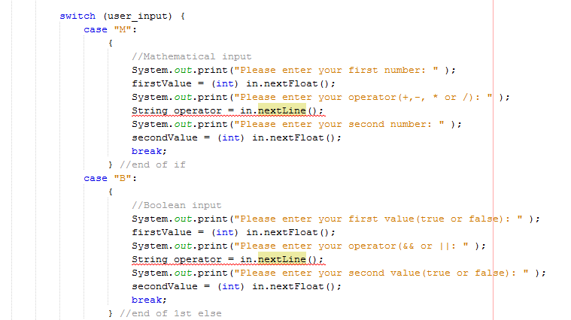

1. Briefly explain how you overcame this error: **FOOP S4 b**

**I overcame this problem by creating different scanner objects for the userinputs- Calculations, int variable and String variable. The calculation user input is for the user to tell the program what type of calculation is required. The int variable user input is for the user to input numbers that need to be solved with an operator. The String variable user input is to store the mathematical operator needed to calculate the problem.**

1. Indicate the output you expect to see before the program is compiled and record the actual output from running your final program in the table below:

**FOOP S4 c PDP S3 a**

|  |  |  |  |  |  |
| --- | --- | --- | --- | --- | --- |
| **Test Scenario** | **Input A** | **Input B** | **Operation** | **Provide expected output prior to running your program here:** | **Record actual output from running your final program here:** |
| **A** | **135** | **210** | **+** | **435** |  |
| **B** | **273** | **17** | **-** | **256** |  |
| **C** | **46350** | **50001** | **\*** | **2317546350** |  |
| **D** | **1436** | **13** | **/** | **110.4615384615385** |  |
| **E** | **21** | **51** | **>** | **True** |  |
| **F** | **5** | **18** | **<** | **False** |  |
| **G** | **False** | **True** | **&&** | **True** |  |
| **H** | **False** | **True** | **||** | **True** |  |

1. Provide screenshots of your final programming running using the input data provided in the table above that show the results of the compiled test data used on your coded solution. **FOOP S4 d PDP S3 b**

**Test Scenarios A-H:**

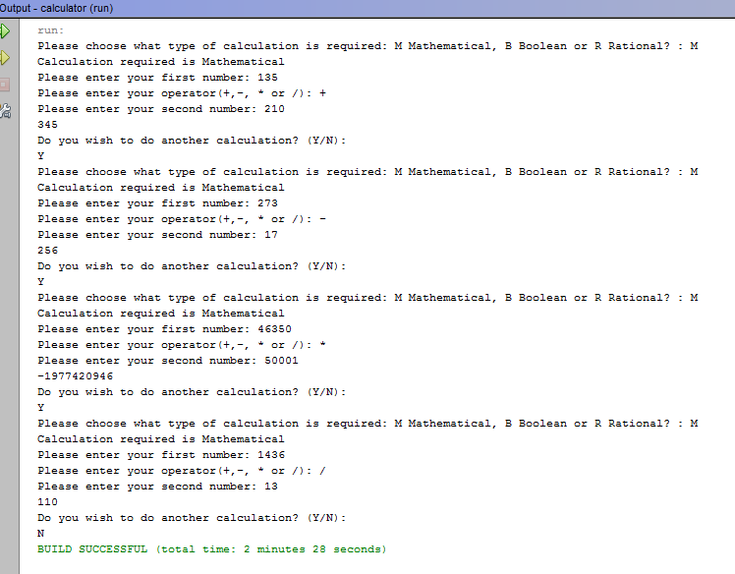

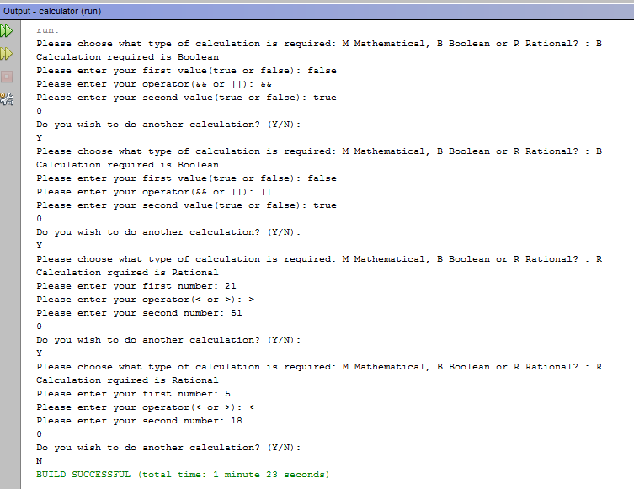

**SECTION FOUR: ACCEPTED INDUSTRY STANDARD FOR CODING**

1. Please provide a well laid out printout of the final program code **with line numbers** showing the following:

* Logical sequence to program following algorithm provided.
* Code suitably commented.
* Indenting conforms to industry standard.

**FOOP S3 c PDP S4 a**

1. Please provide an appropriately cropped and resized screenshot(s) of your **final** program working and insert in the section below:

* Clear and consistent input prompts given to user.
* Clear and consistent output from the program, suitably displayed.

*Input and Output Screenshot displaying Print Formatting:* **FOOP S2 a&b PDP S4 b**